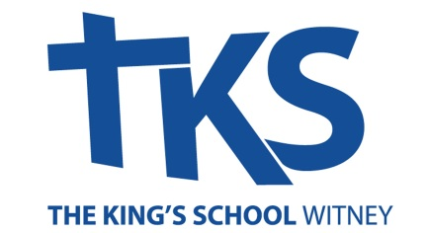

Part-Time Mathematics Teacher (20 Hours per week)
The King’s School, Witney

Post: | Part-Time Mathematics Teacher at The King’s School, Witney, Oxfordshire.  An independent Christian school (3-16) run by Oxfordshire Community Churches
Salary: | FTE £29,994 - £32,178 (Pro Rata £14,996 - £16,088) dependent on hours, qualifications, skills and experience.
Advertised: | Monday 20th April 2026
Closing Date: | Monday18th May, 9AM (Please note that applications will be reviewed as they come in and we reserve the right to close the process at an earlier date.)
Interview date: | TBC
Start date: | 1st September 2026

This is an exciting opportunity to join our successful Christian school staff team, where staff feel supported and valued and where pupils thrive in our community. The King’s School has operated for over 40 years providing high quality Early Years, Primary and Secondary education. Currently the role is 213 pupils.

We are seeking a passionate and skilled teacher to deliver high-quality mathematics lessons and targeted interventions across Key Stage 3 and Key Stage 4. Teaching can be flexible but must be spread over a minimum of four days. Both fully qualified teachers and well-qualified graduates in a relevant subject are equally welcome to apply.

The successful candidate will be an excellent and adaptable practitioner with a servant heart. They will be able to build upon the successes of the past, maintaining the distinctive quality and tone of the school, and will be able to work as part of a strong staff team in line with the vision of Oxfordshire Community Churches. It is therefore a genuine and determining occupational requirement that the post-holder must be a committed Christian, willing to work with others in the context of OCC's ethos statement.
We are committed to safeguarding and promoting the welfare of children and young people. We expect all staff to share this commitment and to undergo appropriate checks. This post is exempt from the Rehabilitation of Offenders Act 1974 and is subject to an Enhanced DBS check with barred list check.
If you have a disability and require any reasonable adjustments that will enable you to apply for this position, then please let us know.

For further information, to arrange an informal visit to the school or to request an application form please contact Francine Smith, Senior Administrator (HR) of The King’s School, office@tkswitney.org.uk or telephone 01993 778463.

